# Data

## Obscured A

* Tree overview

Number of Leaves: 1623

Size of the tree: 1636

* Stratified cross-validation

Correctly Classified Instances 35196 92.2327 %

Incorrectly Classified Instances 2964 7.7673 %

Mean absolute error 0.0114

Root mean squared error 0.0758

Relative absolute error 66.5971 %

Root relative squared error 81.9342 %

Total Number of Instances 38160

* Accuracy by class

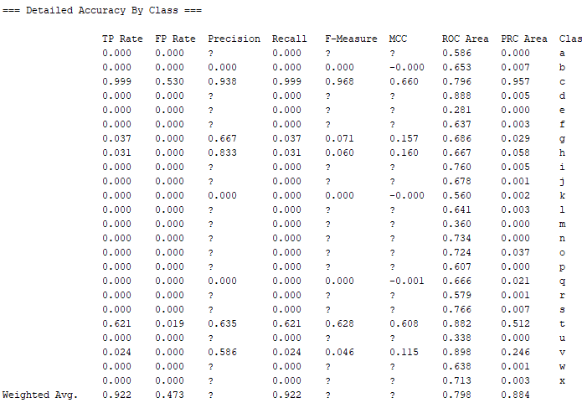

Confusion Matrix

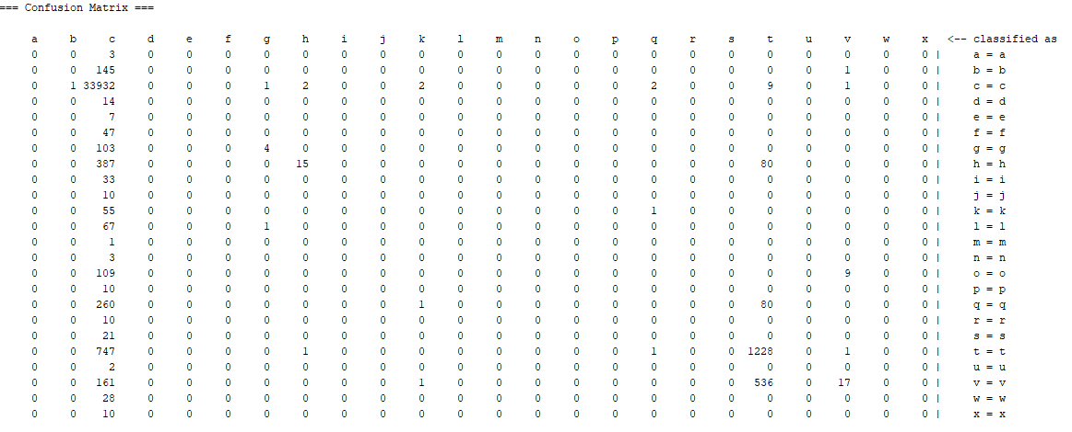

## Obscured B

Tree has one leaf node which is outputting class c

* Tree Overview

Number of Leaves: 1

Size of the tree: 1

* Stratified Cross Validation

Correctly Classified Instances 33950 88.9675 %

Incorrectly Classified Instances 4210 11.0325 %

Mean absolute error 0.0171

Root mean squared error 0.0925

Relative absolute error 99.7443 %

Root relative squared error 99.9999 %

Total Number of Instances 38160

* Accuracy by class

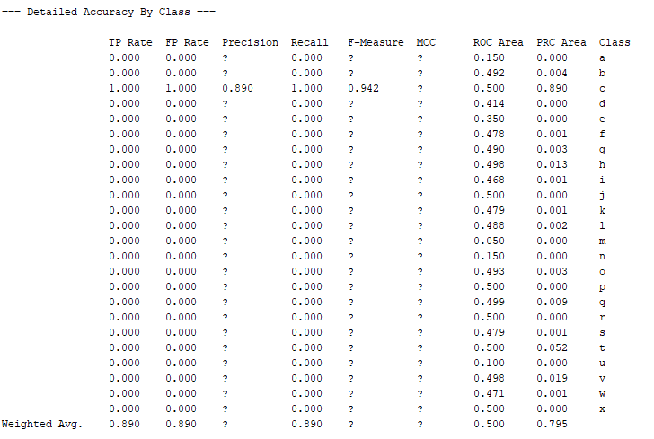

* Confusion Matrix

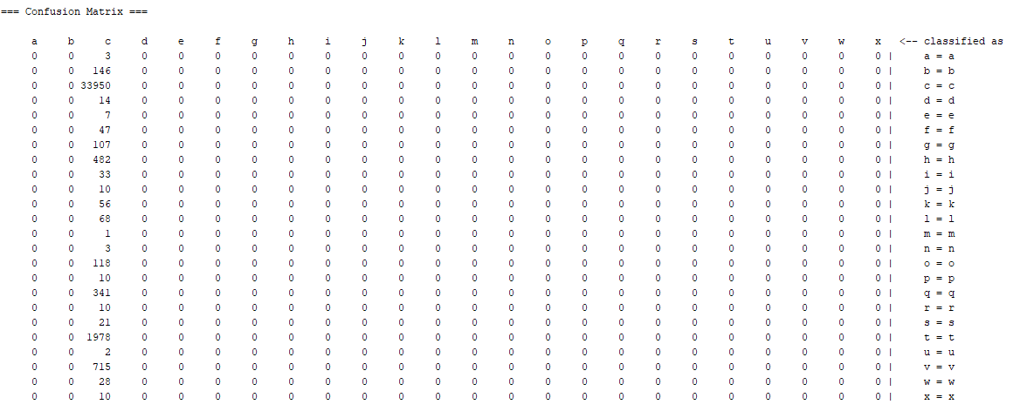

## Obscured A 50

* Tree overview

Number of Leaves: 1620

Size of the tree: 1630

* Stratified Cross Validation

Correctly Classified Instances 17556 92.0126 %

Incorrectly Classified Instances 1524 7.9874 %

Mean absolute error 0.0117

Root mean squared error 0.0769

Relative absolute error 66.5764 %

Root relative squared error 82.3564 %

Total Number of Instances 19080

* Accuracy by class

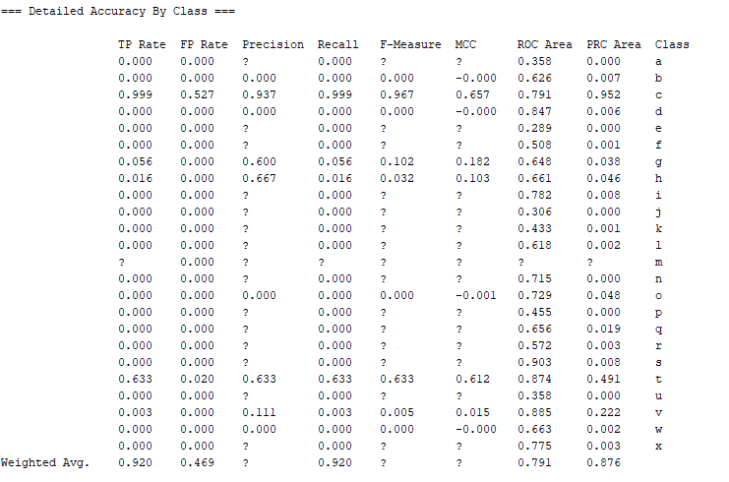

* Confusion matrix

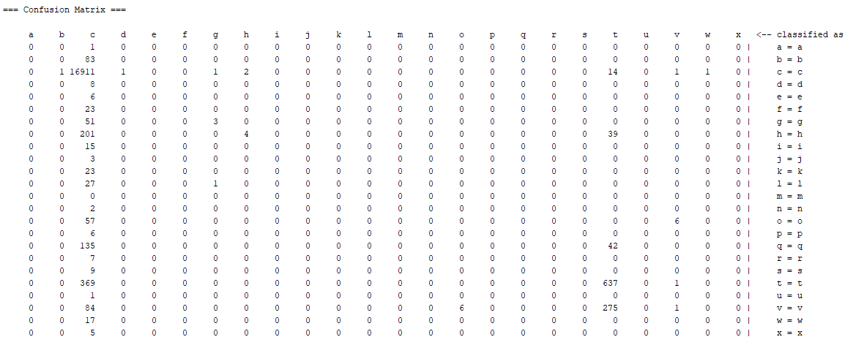

## Obscured B 50

* Tree overview

Number of Leaves: 1

Size of the tree: 1

* Stratified Cross Validation

Correctly Classified Instances 17013 89.1667 %

Incorrectly Classified Instances 2067 10.8333 %

Mean absolute error 0.0168

Root mean squared error 0.0917

Relative absolute error 99.4794 %

Root relative squared error 99.9996 %

Total Number of Instances 19080

* Detailed accuracy by class

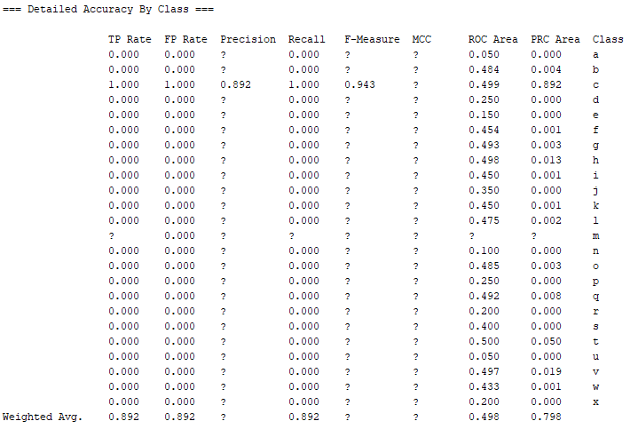

* Confusion Matrix

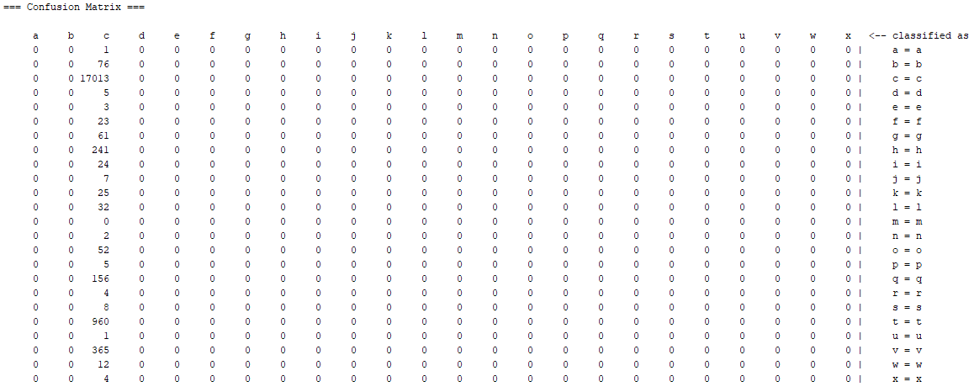

## Obscured A 25

* Tree overview

Number of Leaves : 600

Size of the tree : 604

* Stratified Cross Validation

Correctly Classified Instances 8745 91.6667 %

Incorrectly Classified Instances 795 8.3333 %

Mean absolute error 0.0123

Root mean squared error 0.079

Relative absolute error 66.8191 %

Root relative squared error 82.6962 %

Total Number of Instances 9540

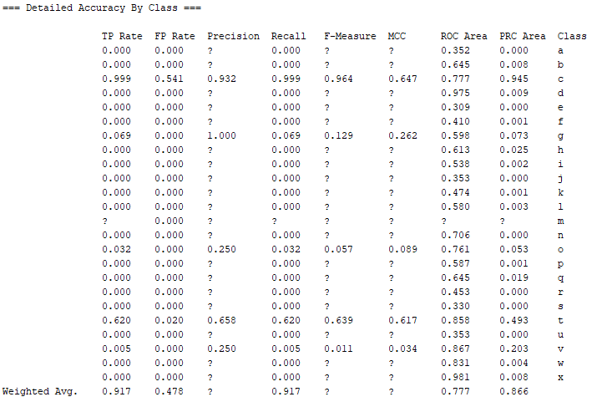

Confusion Matrix

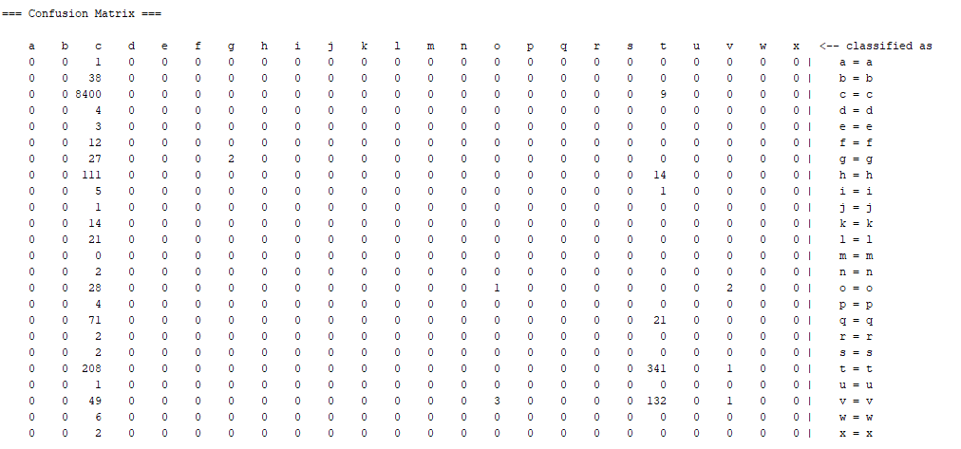

## Obscured B 25

Number of Leaves : 1

Size of the tree : 1

Correctly Classified Instances 8517 89.2767 %

Incorrectly Classified Instances 1023 10.7233 %

Mean absolute error 0.0166

Root mean squared error 0.0912

Relative absolute error 98.9523 %

Root relative squared error 99.9985 %

Total Number of Instances 9540

